**IDENTITY CARD GENERATOR FOR**

**FRANCIS XAVIER ENGINEERING COLLEGE**

**Submitted by SARAN E**

**Abstract:**

The scope of this project is to generate identity card for Francis Xavier Engineering college. In the module 1 it asks the user to enter the details of the student and upload his/her image as well .Once the details are entered and the save button is clicked it will take us to the next Module. The details of the students will be displayed in the respective labels of the Module 2. And also it is exactly the same as the Identity cards of the Francis Xavier Engineering college.

**Software used:**

Language : Core Java.

IDE : Visual Studio Code.

DataBase : MySql.

Server : Xampp Server.

**JAVA CODE :**

**MODULE 1:**

import **java**.**awt**.**Color**;

import **java**.**awt**.**Image**;

import **java**.**awt**.**Font**;

import **java**.**awt**.**event**.*;

import **java**.**sql**.**Statement**;

import **java**.**io**.**File**;

import **java**.**sql**.**Connection**;

import **java**.**sql**.**DriverManager**;

import **javax**.**swing**.**ImageIcon**;

import **javax**.**swing**.**JButton**;

import **javax**.**swing**.**JFileChooser**;

import **javax**.**swing**.**JFrame**;

import **javax**.**swing**.**JLabel**;

import **javax**.**swing**.**JTextField**;

import **javax**.**swing**.**filechooser**.**FileNameExtensionFilter**;

public class **Id**  implements **ActionListener**

{

    public **JLabel** l1,l2,l3,l4,l5,l6,l7,l8,l9,l10,lp,l11,l12,l13,l14;

    public **JTextField** t1,t2,t3,t4,t5,t6,t7,t8,t9,t10;

    public **JButton** b1,b2,b3,b4;

**JFrame** f;

**String** path;

    public void **Idcard**()

    {

            f = new **JFrame**("Details");

            f.**getContentPane**().**setBackground**(**Color**.cyan);

**Font** f1 = new **Font**("Verdana",**Font**.BOLD,10);

**Font** f2 = new **Font**("Verdana",**Font**.PLAIN,20);

            l1 = new **JLabel**("Student name : ");

            l2 = new **JLabel**("Reg No :");

            l3 = new **JLabel**("Valid upto :");

            l4 = new **JLabel**("Departement :");

            l5 = new **JLabel**("Blood group :");

            l6 = new **JLabel**("Date of birth         :");

            l7 = new **JLabel**("Phone no :");

            l8 = new **JLabel**("Hos/DayScholar :");

            l9 = new **JLabel**("Father's name   :");

            l10 = new **JLabel**("Address             :");

            l11 = new **JLabel**("Upload image :");

            lp = new **JLabel**();

            l12 = new **JLabel**();

            l12.**setIcon**(new **ImageIcon**("D:\\idcard\\scad2.png"));

            l13 = new **JLabel**("FXEC ID CARD");

            l14 = new **JLabel**("GENERATOR");

            l1.**setBounds**(50,50,100,30);

            l2.**setBounds**(50,120,100,30);

            l3.**setBounds**(50,190,100,30);

            l4.**setBounds**(50,260,100,30);

            l5.**setBounds**(50,330,100,30);

            l6.**setBounds**(350,50,100,30);

            l7.**setBounds**(350,120,100,30);

            l8.**setBounds**(350,190,100,30);

            l9.**setBounds**(350,260,100,30);

            l10.**setBounds**(350,330,100,30);

            l11.**setBounds**(50,400,100,30);

            l12.**setBounds**(700,150,200,200);

            lp.**setBounds**(150,200,120,140);

            l13.**setBounds**(740,350,400,50);

            l14.**setBounds**(750,390,400,50);

            l13.**setFont**(f1);

            l13.**setFont**(f2);

            l13.**setForeground**(**Color**.blue);

            l14.**setFont**(f1);

            l14.**setFont**(f2);

            l14.**setForeground**(**Color**.blue);

            t1 = new **JTextField**();

            t2 = new **JTextField**();

            t3 = new **JTextField**();

            t4 = new **JTextField**();

            t5 = new **JTextField**();

            t6 = new **JTextField**();

            t7 = new **JTextField**();

            t8 = new **JTextField**();

            t9 = new **JTextField**();

            t10 = new **JTextField**();

            t1.**setBounds**(200,50,100,30);

            t2.**setBounds**(200,120,100,30);

            t3.**setBounds**(200,190,100,30);

            t4.**setBounds**(200,260,100,30);

            t5.**setBounds**(200,330,100,30);

            t6.**setBounds**(500,50,100,30);

            t7.**setBounds**(500,120,100,30);

            t8.**setBounds**(500,190,100,30);

            t9.**setBounds**(500,260,100,30);

            t10.**setBounds**(500,330,100,30);

            b1 = new **JButton**("Save");

            b2 = new **JButton**("Clear");

            b3 = new **JButton**("Upload");

            b4 = new **JButton**("empty");

            b1.**setBounds**(200,520,100,30);  *//save*

            b2.**setBounds**(500,520,100,30);  *//cancel*

            b3.**setBounds**(200,400,100,30);  *//upload*

            b4.**setBounds**(300,100,100,30);

            b3.**setBackground**(**Color**.white);

            b1.**addActionListener**(this);

            f.**add**(l1);        f.**add**(l2);

            f.**add**(l3);         f.**add**(l4);

            f.**add**(l5);            f.**add**(l6);

            f.**add**(l7);            f.**add**(l8);

            f.**add**(l9);            f.**add**(l10);

            f.**add**(l11);            f.**add**(l12);

            f.**add**(l13);            f.**add**(l14);

            f.**add**(t1);            f.**add**(t2);

            f.**add**(t3);            f.**add**(t4);

f.**add**(t5);            f.**add**(t6);

            f.**add**(t7);            f.**add**(t8);

            f.**add**(t9);            f.**add**(t10);

            f.**add**(b1);            f.**add**(b2);

            f.**add**(b3);              f.**add**(b4);

            f.**setVisible**(true);

            f.**setLayout**(null);

            f.**setSize**(1100,650);

            f.**setLocationRelativeTo**(null);

          f.**setDefaultCloseOperation**(**JFrame**.EXIT_ON_CLOSE);

            b3.**addActionListener**(new **ActionListener**()

            {

                public void **actionPerformed**(**ActionEvent** e)

                {

**JFileChooser** file = new **JFileChooser**();

                    file.**setCurrentDirectory**(new **File**(**System**.**getProperty**("user.home")));

**FileNameExtensionFilter** filter = new **FileNameExtensionFilter**("*.Images","jpg","gif","png");

                    file.**addChoosableFileFilter**(filter);

                    int result = file.**showSaveDialog**(null);

                    if(result == **JFileChooser**.APPROVE_OPTION)

                    {

**File** selectedFile = file.**getSelectedFile**();

                        path = selectedFile.**getAbsolutePath**();

                        lp.**setIcon**(**ResizeImage**(path));

                    }

                    else if(result == **JFileChooser**.CANCEL_OPTION)

                    {

**System**.out.**println**("No File Select");

                    }

                }

            });

      }

    public **ImageIcon** **ResizeImage**(**String** ImagePath)

    {

**ImageIcon** MyImage = new **ImageIcon**(ImagePath);

**Image** img = MyImage.**getImage**();

**Image** newImg = img.**getScaledInstance**(lp.**getWidth**(),lp.**getHeight**(), **Image**.SCALE_SMOOTH);

**ImageIcon** image = new **ImageIcon**(newImg);

        return image;

    }

    public void **actionPerformed**(**ActionEvent** e)

    {

**Object** s = e.**getSource**();

        if(s == b1)

        {

**Data**.t1 = t1.**getText**();

**System**.out.**println**(**Data**.t1);

**Data**.t2 = t2.**getText**();

**System**.out.**println**(**Data**.t2);

**Data**.t3 = t3.**getText**();

**System**.out.**println**(**Data**.t3);

**Data**.t4 = t4.**getText**();

**System**.out.**println**(**Data**.t4);

**Data**.t5 = t5.**getText**();

**System**.out.**println**(**Data**.t5);

**Data**.t6 = t6.**getText**();

**System**.out.**println**(**Data**.t6);

**Data**.t7 = t7.**getText**();

**System**.out.**println**(**Data**.t7);

**Data**.t8 = t8.**getText**();

**System**.out.**println**(**Data**.t8);

**Data**.t9 = t9.**getText**();

**System**.out.**println**(**Data**.t9);

**Data**.t10 = t10.**getText**();

**System**.out.**println**(**Data**.t10);

**Data**.lp = lp.**getIcon**();

**System**.out.**println**(**Data**.lp);

            new **Displayid**().**Idshow**();

            f.**dispose**();

**String** studentname = t1.**getText**();

**String** regno = t2.**getText**();

**String** valid = t3.**getText**();

**String** dept = t4.**getText**();

**String** bg = t5.**getText**();

**String** dob = t6.**getText**();

**String** phone = t7.**getText**();

**String** hosorday = t8.**getText**();

**String** father = t9.**getText**();

**String** address = t10.**getText**();

**String** image = path;

            image = image.**replace**("\\", "\\\\");

            try

            {

**Class**.**forName**("com.mysql.jdbc.Driver");

**System**.out.**println**("Driver found");

**Connection** con = **DriverManager**.**getConnection**("jdbc:mysql://localhost:3306/id","root","");

**System**.out.**println**("Connected");

**Statement** st = con.**createStatement**();

                st.**executeUpdate**("insert into idtable values('"+studentname+"','"+regno+"','"+valid+"','"+dept+"','"+bg+"','"+dob+"','"+phone+"','"+hosorday+"','"+father+"','"+address+"','"+image+"')");

**System**.out.**println**("Added");

            }

            catch(**Exception** ae)

            {

**System**.out.**println**("Driver not found");

            }

        }

    }

    public static void **main**(**String**[] args)

    {

        new **Id**().**Idcard**();

    }

}

**MODULE 2 :**

import **javax**.**swing**.**ImageIcon**;

import **javax**.**swing**.**JFrame**;

import **javax**.**swing**.**JLabel**;

import **javax**.**swing**.**JPanel**;

import **java**.**awt**.*;

public class **Displayid**

{

    public void **Idshow**()

    {

**JLabel** lp,l0,l01,l02,l03,l1,l2,l3,l4,l5,l6,l7,l8,l9,l10,l11,l12,l13,l14,l15,l16,l17,l18,l19,l20,l21,l22,l23,l24,l25,l26,l27;

**JPanel** p = new **JPanel**();    *//Photo*

**JPanel** p2 = new **JPanel**();

**JPanel** p3 = new **JPanel**(); *//Pink*

**Font** f1 = new **Font**("Verdana",**Font**.BOLD,25);

**Font** f2 = new **Font**("Serif",**Font**.PLAIN,5);

**Font** f3 = new **Font**("Serif",**Font**.BOLD,15);

**Font** f4 = new **Font**("Serif",**Font**.PLAIN,5);

**Font** f5 = new **Font**("Serif",**Font**.BOLD,15);

        p.**setBounds**(240,70,350,550);

        p.**setBackground**(**Color**.white);

        p2.**setBounds**(790,70,350,550);

        p2.**setBackground**(**Color**.white);

**JFrame** f = new **JFrame**("ID CARD ");

        f.**getContentPane**().**setBackground**(**Color**.LIGHT_GRAY);

        l0 = new **JLabel**("  ISO 9001:2015 Certified|DST-FIST Supported Institution");

        l01 = new **JLabel**(" Recognized under Section 2(f) & 12(B) of the UGC Act. 1956");

        l02 = new **JLabel**("  Vannarpettai,Tirunelveli-627003,TamilNadu");

        l03 = new **JLabel**("Principal");

*// l04 = new JLabel("vel");*

        l1 = new **JLabel**(**Data**.t1);

        l2 = new **JLabel**(**Data**.t2);

        l3 = new **JLabel**("Valid upto : " + **Data**.t3);

        l4 = new **JLabel**("Departement                     :     "+**Data**.t4);

        l5 = new **JLabel**("Blood group                       :     "+**Data**.t5);

        l6 = new **JLabel**("Date of birth                       :     "+**Data**.t6);

        l7 = new **JLabel**("Phone no                            :     "+**Data**.t7 );

        l8 = new **JLabel**("Hostler/DayScholar          :     "+**Data**.t8);

        l9 = new **JLabel**("Father's name                    :     "+**Data**.t9);

        l10 = new **JLabel**("Address                               :     "+**Data**.t10);

        l11 = new **JLabel**("Instruction :");

        l12 = new **JLabel**("1.Posssesion of identity card is mandatory In Fxec campus.");

        l13 = new **JLabel**("2.In case this card is lost/found kindly Inform/return to Fxec");

        l14 = new **JLabel**("Central Library");

        l15 = new **JLabel**("3.Do not bend this smart card");

        l16 = new **JLabel**("Holders Signature");

        l17 = new **JLabel**("_________________________________________");

        l18 = new **JLabel**("FRANCIS XAVIER ENGINEERING COLLEGE");

        l19 = new **JLabel**("103/G2,Bypass Road,vannarpet");

        l20 = new **JLabel**("Tirunelveli 627003,Tamilnadu,India");

        l21 = new **JLabel**("Phone : +91 462 2502283 , 2502157");

        l22 = new **JLabel**("Fax : +91 462 2501007");

        l23 = new **JLabel**("Email : principal@Francisxavier.ac.in");

        l24 = new **JLabel**("www.francisxavier.ac.in");

        l25 = new **JLabel**();

        l25.**setIcon**(new **ImageIcon**("D:\\idcard\\fxlogo.png"));

        l26 = new **JLabel**();

        l26.**setIcon**(new **ImageIcon**("D:\\idcard\\becsesame.jpg"));

        l27 = new **JLabel**();

        l27.**setIcon**(new **ImageIcon**("D:\\idcard\\pink box 2.jpg"));

        lp = new **JLabel**(**Data**.lp);

        lp.**setBounds**(120,200,120,140);*//photo*

        l0.**setBounds**(15,100,500,30);

        l01.**setBounds**(5,120,500,30);

        l02.**setBounds**(40,140,500,30);

        l03.**setBounds**(270,500,100,30);

        l1.**setBounds**(150,360,500,30);

        l2.**setBounds**(150,390,500,30);

        l3.**setBounds**(110,420,500,30);

        l4.**setBounds**(10,20,500,30);

        l5.**setBounds**(10,45,500,30);

        l6.**setBounds**(10,70,500,30);

        l7.**setBounds**(10,95,500,30);

        l8.**setBounds**(10,120,500,30);

        l9.**setBounds**(10,145,500,30);

        l10.**setBounds**(10,170,500,30);

        l11.**setBounds**(10,200,100,30);

        l12.**setBounds**(10,220,500,50);

        l13.**setBounds**(10,245,500,50);

        l14.**setBounds**(10,270,500,50);

        l15.**setBounds**(10,295,500,50);

        l16.**setBounds**(230,325,120,30);

        l17.**setBounds**(0,350,500,30);

        l18.**setBounds**(15,375,500,40);

        l19.**setBounds**(70,400,500,40);

        l20.**setBounds**(60,420,500,40);

        l21.**setBounds**(60,440,500,40);

        l22.**setBounds**(100,460,500,40);

        l23.**setBounds**(60,480,500,40);

        l24.**setBounds**(100,500,500,40);

        l25.**setBounds**(-10,-5,400,100);

        l26.**setBounds**(315,200,150,200);

        l27.**setBounds**(-80,140,500,600);

l1.**setForeground**(**Color**.red);

        l17.**setFont**(f1);

        l18.**setFont**(f2);

        l18.**setFont**(f3);

        l18.**setForeground**(**Color**.red);

        l19.**setFont**(f4);

        l20.**setFont**(f4);

        l21.**setFont**(f4);

        l22.**setFont**(f4);

        l23.**setFont**(f4);

        l24.**setFont**(f4);

        l19.**setFont**(f5);

        l20.**setFont**(f5);

        l21.**setFont**(f5);

        l22.**setFont**(f5);

        l23.**setFont**(f5);

        l24.**setFont**(f5);

        f.**add**(p);  f.**add**(lp);

        f.**add**(p2);  f.**add**(p3);

        p.**add**(lp);  p.**add**(p3);

        p.**add**(l0);  p.**add**(l01);

        p.**add**(l02);.**add**(l03);

        p.**add**(l1);  p.**add**(l2);

p.**add**(l3);  p2.**add**(l4);

        p2.**add**(l5);  p2.**add**(l6);

        p2.**add**(l7);  p2.**add**(l8);

        p2.**add**(l9);  p2.**add**(l10);

        p2.**add**(l11);  p2.**add**(l12);

        p2.**add**(l13);.**add**(l14);

        p2.**add**(l15);  p2.**add**(l16);

        p2.**add**(l17);  p2.**add**(l18);

        p2.**add**(l19);.**add**(l20);

        p2.**add**(l21);  p2.**add**(l22);

        p2.**add**(l23); p2.**add**(l24);

        p.**add**(l25);  p.**add**(l26);

        p.**add**(l27);

        p.**setLayout**(null);

        p.**setVisible**(true);

        p2.**setLayout**(null);

        p2.**setVisible**(true);

        p3.**setLayout**(null);

        p3.**setVisible**(true);

        f.**setLayout**(null);

        f.**setSize**(1580,1080);

        f.**setVisible**(true);

        f.**setDefaultCloseOperation**(**JFrame**.EXIT_ON_CLOSE);

    }

    public static void **main**(**String**[] args)

    {

        new **Displayid**().**Idshow**();

    }

}

**Module 1 :** 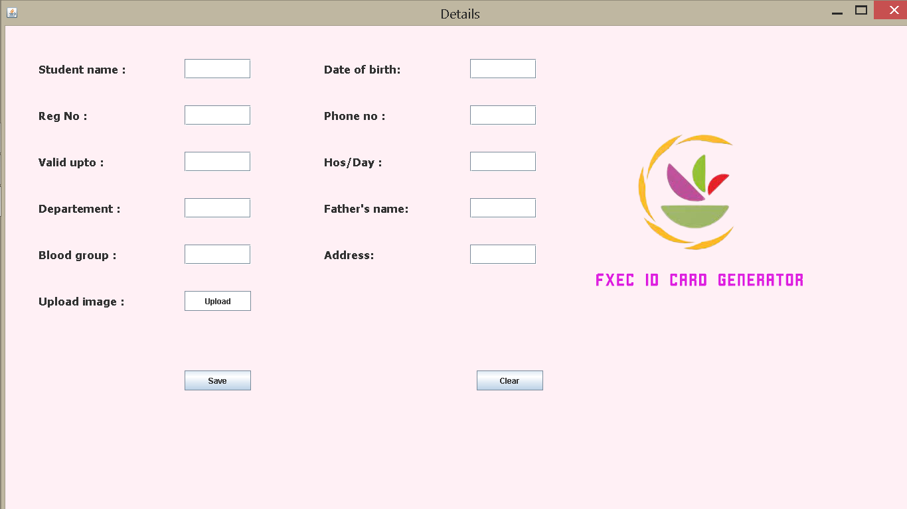This Module 1 asks the user to enter the Details of the students.

**MODULE 2 :** 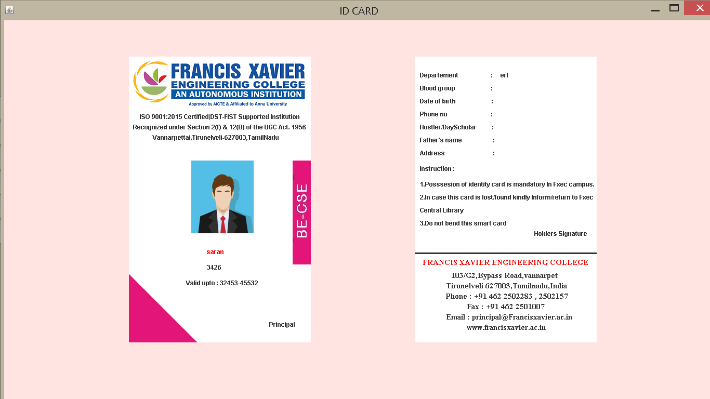

Module 2 will generate the details that given in the previous module.

**Database :**

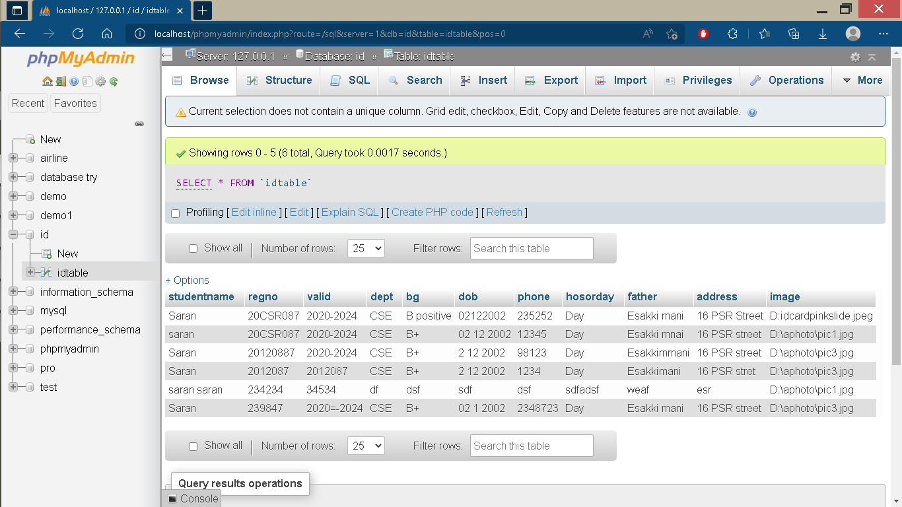

This is the Data’s that user have entered.

**Conclusion :**

The Id card generator has successfully generated the details of the student that user provided. And the entered details also be stored in the database successfully . Hope in future it will generate the id card of both the staffs and students id card of all the college.